Embassy Suites Columbus Airport

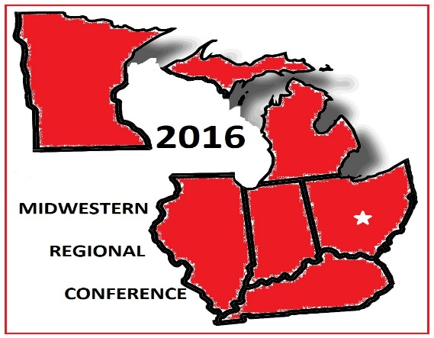Hotel Reservation Instructions





**“STATE OF THE BLACK HEALTH: LIVING WELL IN THE 21ST CENTURY”**

**Choice One:**

1. Call the Hotel at 614-536-0500
2. Tell them you want to make a reservation under Group Code: BBD

**Choice Two:**

Open the link, (copy and paste)[**http://embassysuites3.hilton.com/en/hotels/ohio/embassy-suites-by-hilton-columbus-airport-CMHATES/index.html**](http://embassysuites3.hilton.com/en/hotels/ohio/embassy-suites-by-hilton-columbus-airport-CMHATES/index.html)

Select the correct dates **(Between August 4 and August 7)**

Select how many rooms

Select how many people

Click on **“add special rate code”**

Put **BBD** under **Group Code (press Enter button)**

2886 Airport Drive

Columbus, OHio

Group Code: **BBD**

Phone**: 614-536-0500**