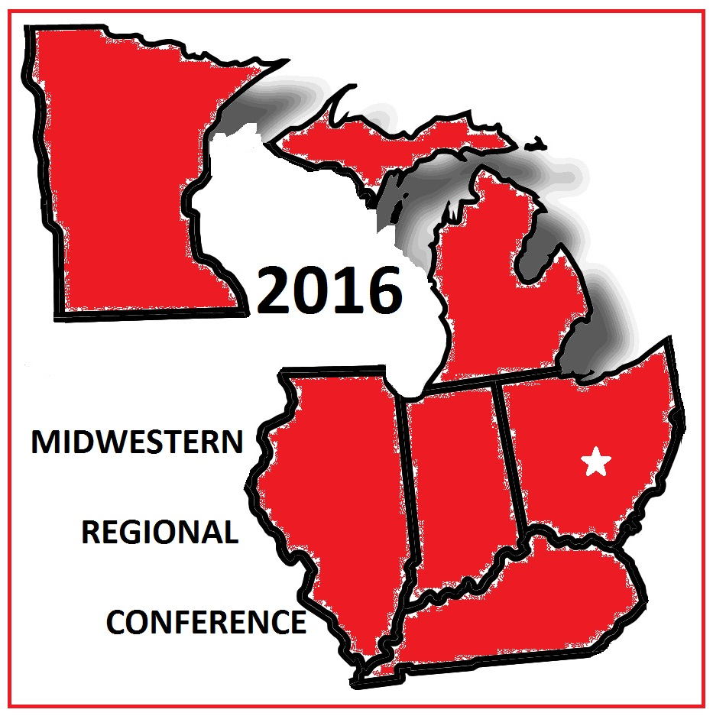
Illinois • Indiana • Kentucky • Michigan • Minnesota • Ohio
Black Health
Active
Lifestyle
2016 MIDWESTERN REGIONAL CONFERENCE
State of the Black Health: Living Well in the 21st Century
AUGUST 5 – 7, 2016
EMBASSY SUITES COLUMBUS
2886 Airport Drive
Columbus, Ohio
Dear Prospective Sponsor,

It is with great excitement to announce that the Buckeye Black Deaf Advocates Chapter (BBDA) of the National Black Deaf Advocates, Inc (NBDA) will host the Midwestern Conference August 5, 2016 – August 7, 2016, at the Embassy Suites, 2886 Airport Dr., Columbus, Ohio. Our conference theme is "State of Black Health: Living Well In the 21st Century" A variety of workshops and activities will be offered, focusing on knowledge, awareness and skill development in the areas of health and fitness. It will be our chapter’s first time hosting the Midwestern Regional Conference in Columbus. Our Midwestern Regional states are Indiana, Illinois, Michigan, Kentucky, Minnesota and Ohio. More information about our upcoming conference can be found at (http://buckeyebda20.weebly.com). It is with hope that our conference attendees will leave the conference feeling empowered and inspired to lead an active and healthy lifestyle.

NBDA is the leading advocacy organization for thousands of Black deaf and hard of hearing people in the United States. It was established in 1982 because Black deaf leaders were concerned that deaf and hard of hearing African-Americans were not adequately represented in leadership and policy decision making activities affecting their lives. Our mission is to promote the leadership development, economic and educational opportunities, social equality, and to safeguard the general health and welfare of Black deaf and hard of hearing people. You can read more about NBDA at www.nbda.org .

The objective of this letter is to request your sponsorship of the 2016 Midwest Regional Conference. We’re requesting financial, services or products contributions. Your contribution will help pay for special guest speakers, program books, gift bags, interpreters, door-prize gifts (that will propose health and fitness), food and other pertinent costs. At your request, we will provide supporting documentation that we are a non-profit organization, as well as our NBDA federal employer identification number if you are considering a financial donation. Please see next page for financial sponsorship levels recognitions. Your support of our conference, whether it is financial and/or in-kind items/services, will help make us one of the best and memorable Midwestern Regional Conferences.

Your investment and contribution in our conference will serve as an inspiration to our Deaf Black community that you care and support what we are aiming to do about black health and wellness. Please feel free to e-mail me at 2016mwrchair@gmail.com if you have any further questions. We look forward to hearing from you before June 1, 2016. Thank you for taking the time to read this letter. May the year 2016 bring your business much success and prosperity.

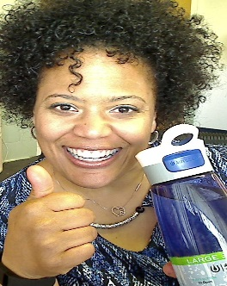
Best Regards,

Stephanie Smith Albert
2016 Midwestern Regional Conference Chair
MIDWESTERN REGIONAL CONFERENCE SPONSORSHIP LEVELS

GOLD LEVEL SPONSORSHIP--$1000.00+

- This sponsorship category receives penultimate recognition as a top conference sponsor during the conference at the following events and features: opening ceremony, luncheon, conference program book, closing ceremony and conference signage in various locations;
- Complimentary exhibit space during the entire conference;
- Company Logo and link on Buckeye Black Deaf Advocates webpage and Facebook
- Two (2) full pages color ad in the conference program book;
- An engraved plaque as a token of our appreciation for sponsorship;
- Five (5) complimentary registration combo tickets to the conference; and
- Five (5) persons receiving VIP seating for all events

SILVER LEVEL SPONSORSHIP--$500.00+

- This sponsorship category receives recognition as a Silver sponsor during the conference at the following events and features: opening ceremony, luncheon, conference program book, closing ceremony and conference signage near registration area;
- Complimentary exhibit space during the entire conference;
- Company Logo and link on Buckeye Black Deaf Advocates webpage and Facebook
- One (1) full page color ad in the conference program book;
- A framed certification of appreciation for sponsorship;
- Two (2) complimentary registration combo tickets to the conference; and
- Two (2) persons receiving VIP seating for all events

BRONZE LEVEL SPONSORSHIP--$250.00+

- This sponsorship category receives recognition as a Bronze sponsor during the conference at the following events and features: opening ceremony, luncheon, conference program book, closing ceremony and conference signage near registration area;
- Complimentary exhibit space during the entire conference;
- Company Logo and link on Buckeye Black Deaf Advocates webpage and Facebook
- Half-page color ad in the conference program book;
- A framed certification of appreciation for sponsorship;
- One (1) complimentary registration combo ticket to the conference; and
- One (1) person receiving VIP seating for all events

Illinois • Indiana • Kentucky • Michigan • Minnesota • Ohio
Black Health
Active
Lifestyle
2016 MIDWESTERN REGIONAL CONFERENCE
State of the Black Health: Living Well in the 21st Century
AUGUST 5 – 7, 2016
EMBASSY SUITES COLUMBUS
2886 Airport Drive
Columbus, Ohio

Sponsorship Form

Company/Organization Name: _________________________________________________________

Contact Name: ______________________________________________________________________

Title: _____________________________________________________________________________

Mailing Address: ___________________________________________________________________

City: _______________________________ State: _______ Zip Code: _______________________

Telephone/Videophone: _____________________________________________________________

Fax Number: ______________________________________________________________________

Email Address: ____________________________________________________________________

Web site: _________________________________________________________________________

Please select the form of payment: Business Check_____ Cashier’s Check_____ Money Order_____

TOTAL AMOUNT ENCLOSED: $__________________________________

Signature: __________________________________________________ Date: _________________

Names of Representative(s) who will be at this event: (1.) _____________________________________
(2.) ____________________________ (3.) ___________________________ (4.)__________________________
(5.) ____________________________

Make your check or money order payable to: National Black Deaf Advocates (NBDA)

On the memo line of your check, please write: 2016 Midwestern Regional Conference-BBDA

Mail this form with your check or money to: 2016 Midwestern Regional Conference Sponsorship
201 Wilcrest Dr. #1401
By June 1, 2016 Houston, TX 77042
Attn: Betty Henderson, NBDA Treasurer
THANK YOU FOR YOUR GENEROUS SUPPORT OF THE 2016 MIDWESTERN REGIONAL CONFERENCE!!

